**SMART HYDROPONICS: INTEGRATING NUTRIENT LEVEL AND PH LEVEL SENSOR WITH CAMERA-BASED PEST DETECTION SYSTEM**

An

Application Development Project

Presented to the Faculty of

**Mindoro State University Calapan City Campus**

Masipit, Calapan City

Oriental Mindoro

In Partial Fulfillment

of the Requirements for the Degree

Bachelor of Science in Information Technology

by:

**Ian Chris A. Sandoval**

**Jordan Malibiran**

**Jade Fabricante**

**Charles Masangkay**

**TABLE OF CONTENTS**

**LIST OF FIGURES**

**LIST OF TABLES**

**LIST OF APPENDICES**

**CHAPTER I**

**INTRODUCTION**

**Project Context**

**Introduction**

Growing your own plants at home can be an exciting and rewarding experience. It allows you to enjoy fresh herbs and vegetables right from your kitchen, enhancing your meals while promoting healthier eating habits. Hydroponics is a method that makes this possible, enabling you to cultivate plants without the need for soil. Instead, plants grow in a nutrient-rich water solution that provides all the essential elements they need to thrive. This approach is particularly appealing for individuals with limited outdoor space or those living in urban environments where traditional gardening isn’t feasible.

While hydroponics offers many advantages, managing a small hydroponic system can be challenging. Keeping track of nutrient levels and pH balance is essential for plant health, as even minor fluctuations can lead to poor growth or crop failure. For those new to hydroponics, the learning curve can be steep, often requiring regular monitoring and adjustments. Additionally, pests can still find their way into indoor or small setups, posing a threat to your plants if not detected early. Traditional methods of pest control can be harmful, particularly for those aiming for a sustainable and organic approach to gardening.

This project, titled “Smart Hydroponics: Integrating Nutrient Level and Ph Level Sensor with Camera-Based Pest Detection System”, aims to address these challenges by simplifying the process of managing a small hydroponic garden. By integrating sensors that continuously monitor nutrient levels and pH, the system ensures that your plants receive optimal conditions for growth without the need for constant manual checks. A basic camera system using ESP32Cam will enhance this further by providing early detection of

pests, sending alerts to users when it identifies potential threats.

The overarching goal is to make hydroponics accessible and manageable for everyone, regardless of their level of gardening experience. With this system, individuals can enjoy the satisfaction of growing their own food at home, with less effort and more confidence in their ability to maintain healthy plants. By empowering hobbyists and beginners with the right tools and knowledge, this project seeks to foster a community of home gardeners who can contribute to sustainable living and food practices.

**Objectives**

The specific objectives of this project are as follows:

1. Design and Development:

- To create a user-friendly smart hydroponic system that integrates nutrient and pH level sensors, enabling users to easily monitor their plants’ health.

2. Automation:

- To automate the process of monitoring nutrient levels and pH balance, ensuring that the system can provide real-time data and alerts without requiring constant manual intervention.

3. Pest Detection:

- To develop a camera-based pest detection system that can identify common pests affecting hydroponic plants, thereby allowing users to address infestations before they cause significant damage.

4. User Alerts:

- To implement an alert system that notifies users via SMS or email when nutrient levels, pH balance, or pest presence falls outside acceptable parameters, helping them take timely action.

5. Evaluation:

- To evaluate the effectiveness of the smart hydroponic system in improving plant health and yield, focusing on user satisfaction, ease of use, and the system’s reliability in different growing conditions.

**Scope and Limitations**

Scope:

- The project focuses on small-scale hydroponic systems designed for home use, catering to hobbyists and beginners interested in growing their own food.

- It will cover the integration of sensors for monitoring essential nutrients (NPK) and pH levels, along with ESP32Cam for detecting pests.

- The system will include a user-friendly interface that displays real-time data, historical records, and alerts to facilitate easy management of the hydroponic garden.

- The project will support common herbs and vegetables such as basil, mint, lettuce, and tomatoes, making it accessible for users interested in a variety of home-grown produce.

Limitations:

- The system will initially target a limited range of crops suitable for hydroponics specifically lettuce and tomatoes; it may not accommodate all plant types or varieties.

- The system will assume stable internet connection and power supply during operation.

- The accuracy of the pest detection camera may vary based on environmental conditions, lighting, and camera positioning, potentially leading to missed detections or false alerts.

- The project may not account for all external factors affecting plant growth, such as fluctuations in temperature, humidity, and light levels, which can impact nutrient uptake and pest behavior.

- Users may require basic technical skills to set up and maintain the system, though the goal is to keep the user experience as straightforward as possible.

**Definition of Terms**

- Hydroponics: A method of growing plants in a nutrient-rich water solution without soil, allowing for efficient use of space and resources.

- Nutrient Level: The concentration of essential nutrients, such as nitrogen, phosphorus, and potassium (NPK), present in the hydroponic solution that supports plant growth.

- pH Level: A measure of how acidic or alkaline the water solution is, which affects the availability of nutrients to plants.

- Pest Detection System: A technology that utilizes a camera to monitor plants for signs of pests, providing alerts when infestations are detected.

- Automation: The use of technology to perform tasks automatically, reducing the need for manual intervention in monitoring and managing the hydroponic system.

- User Interface: The visual elements and controls of the system that allow users to interact with and monitor their hydroponic setup easily.

- Alert System: A notification service that informs users of any critical changes or issues, such as abnormal nutrient levels, pH imbalances, or pest detections.

**CHAPTER II**

**REQUIREMENTS SPECIFICATION**

**Hardware and Software Requirements**

|  |  |  |
| --- | --- | --- |
| **Hardware Component** | **Type** | **Specification** |
| Nutrient Sensor | Sensor | Measures nutrient levels (NPK), provides real-time readings for plant health monitoring. |
| pH Sensor | Sensor | Measures pH levels, compatible with hydroponic nutrient solutions, ensures optimal plant growth. |
| ESP32 | Microcontroller | ESP32-WROOM-32, 32-bit dual-core, 240MHz, Wi-Fi + Bluetooth enabled, 4MB Flash, low-power operation. |
| |  |  |  | | --- | --- | --- | | |  | | --- | | ESP32CAM |  |  | | --- | |  | |  |  | | --- | |  | | |  | | --- | | Vision Sensor |  |  | | --- | |  | | captures images for pest detection with machine learning integration. |
| Jumper Wires | Electrical Wiring | Standard wires for connecting sensors, modules, and microcontroller with reliable signal transmission. |

|  |  |  |  |
| --- | --- | --- | --- |
| **Software Component** | **Type** | **Minimum Specification** | **Recommended Specification** |
| Express.js | Backend Framework | |  | | --- | | Version 12.0 or higher | | |  | | --- | | Version 12.0 or higher | |
| MongoDB | |  | | --- | | Database | | |  | | --- | | Version 4.2 or higher | | |  | | --- | | Version 6.0 or higher, with MongoDB Atlas for cloud hosting | |
| Vue.js | |  | | --- | | Frontend Framework | | |  | | --- | | Frontend Framework | | |  | | --- | | Frontend Framework | |

**Functional Requirements**

1. Nutrient and pH Monitoring:

- The system shall continuously monitor nutrient levels, specifically nitrogen, phosphorus, and potassium (NPK), and the pH level of the hydroponic solution.

- Real-time readings shall be displayed on the dashboard in user-friendly graphs or numerical formats.

- Users shall be able to set target ranges for nutrient levels and pH, with the system providing visual indicators (e.g., green for acceptable levels, yellow for warning, red for critical).

2. Pest Detection:

- The camera shall capture images of the plants at defined intervals (e.g., every 15 minutes).

- An image processing algorithm shall analyze the captured images to detect common pests such as aphids, spider mites, and whiteflies.

- If pests are detected, the system shall send immediate alerts to the user via SMS and/or email, including a timestamp and a reference image.

3. Automated Alerts:

- The system shall send notifications to the user when:

- Nutrient levels fall below or exceed the defined target range.

- pH levels fall below 5.5 or exceed 7.0, indicating potential stress for the plants.

- Pests are detected in the monitoring images.

- Users shall have the option to customize alert thresholds and notification methods (SMS, email, or app notification).

4. User Interface:

- The dashboard shall provide a clear overview of current nutrient levels, pH levels, and pest status.

- Users shall be able to view historical data for nutrient levels and pH over time, with the option to download reports.

- The interface shall allow users to easily configure settings, including alert thresholds and camera intervals.

5. Data Storage and Access:

- The system shall store sensor data and images for a minimum of 30 days for user reference.

- Users shall be able to access and review historical data through the dashboard, with the option to filter by date or specific parameters.

**Non-Functional Requirements**

Operational Requirement

- The system shall be designed for easy installation, allowing users to set it up within 30 minutes without advanced technical skills.

- It should operate 24/7 with minimal downtime, ensuring continuous monitoring of plant conditions.

Performance Requirement

- The system must provide updates on nutrient and pH levels at least every 5 minutes.

- The pest detection algorithm should achieve at least 90% accuracy in identifying common pests based on tested images.

- Alerts should be delivered to users within 1 minute of detecting an anomaly.

Security Requirement

- All data communication between sensors, the camera, and the dashboard must be encrypted to protect user data.

- User accounts shall be secured with a password and, if possible, two-factor authentication for added security.

- Access to historical data and system settings shall be restricted based on user roles (e.g., admin vs. user).

Cultural Requirement (if Applicable)

- The user interface shall be available in multiple languages to accommodate diverse users.

- User documentation shall include clear, step-by-step instructions with visuals to assist users of varying technical backgrounds.

**CHAPTER III**

**Design and Development Methodologies**

**System Design**

The Smart Hydroponics System integrates sensors, Internet of Things devices, and an intuitive user interface to monitor and improve hydroponic development. This system records important parameters such as pH and NPK (nitrogen, phosphorus, and potassium) levels, takes pictures of plants, processes data in real time, and notifies users.

**Database Design**

The database design for the smart hydroponics system is set up to handle and store important data gathered from different, sensors, and camera. The database acts as the system's backbone, making sure that user settings, sensor data, and plant photos are effectively processed and saved for analysis.

The MongoDB, a NoSQL database selected for its scalability and flexibility, forms the foundation of the database. The hydroponic system's sensor readings (pH and NPK levels), plant photos taken with the ESP32Cam, and user preferences (such notification threshold settings) are all stored in this database.

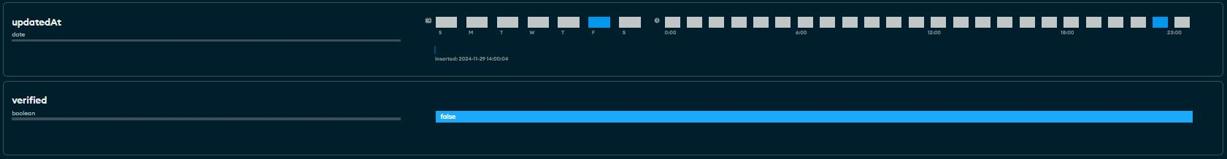

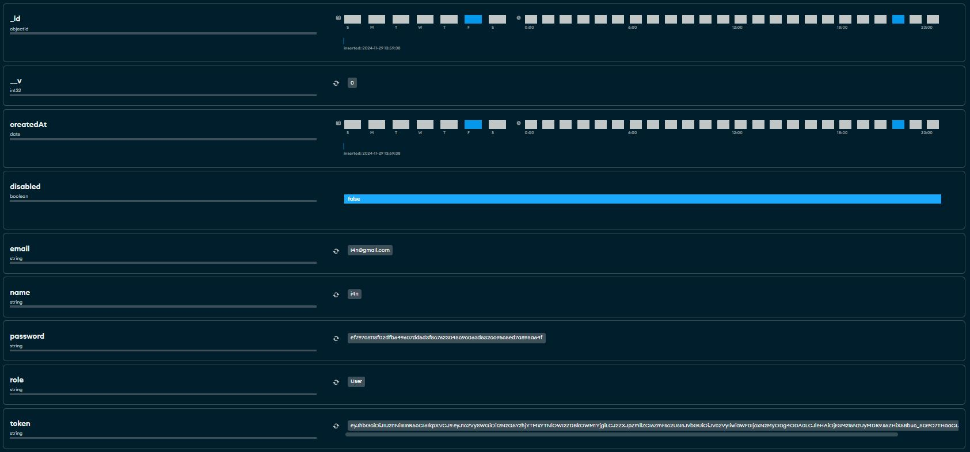

**Table 1. Fields for User**

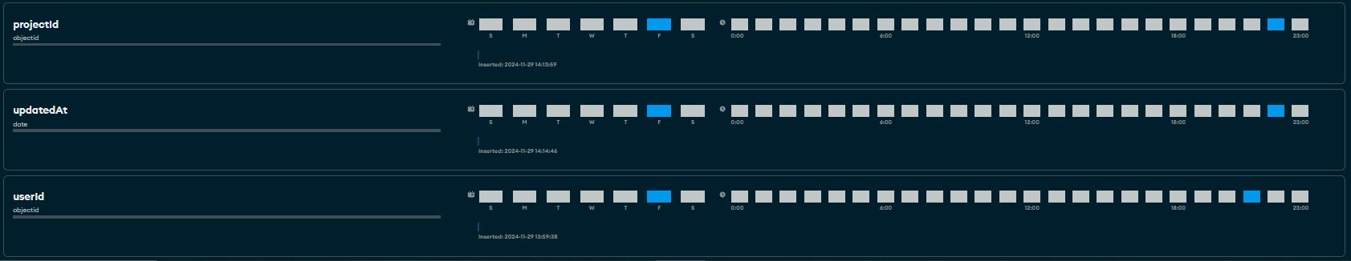

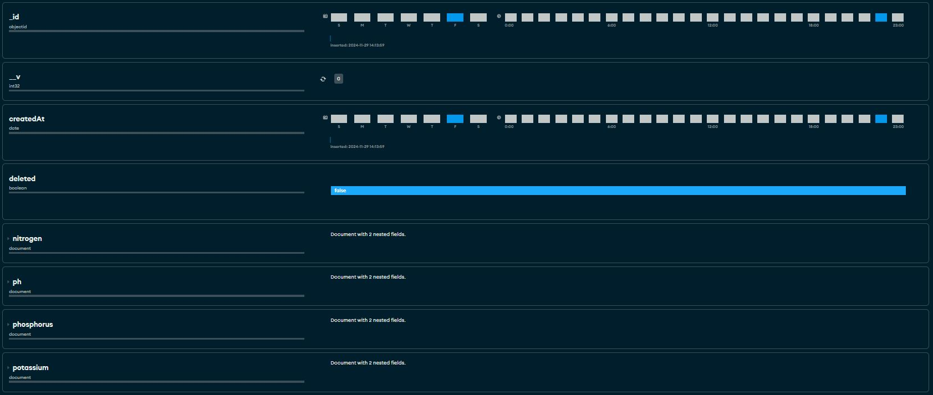

**Table 2. Fields for Thresholds**

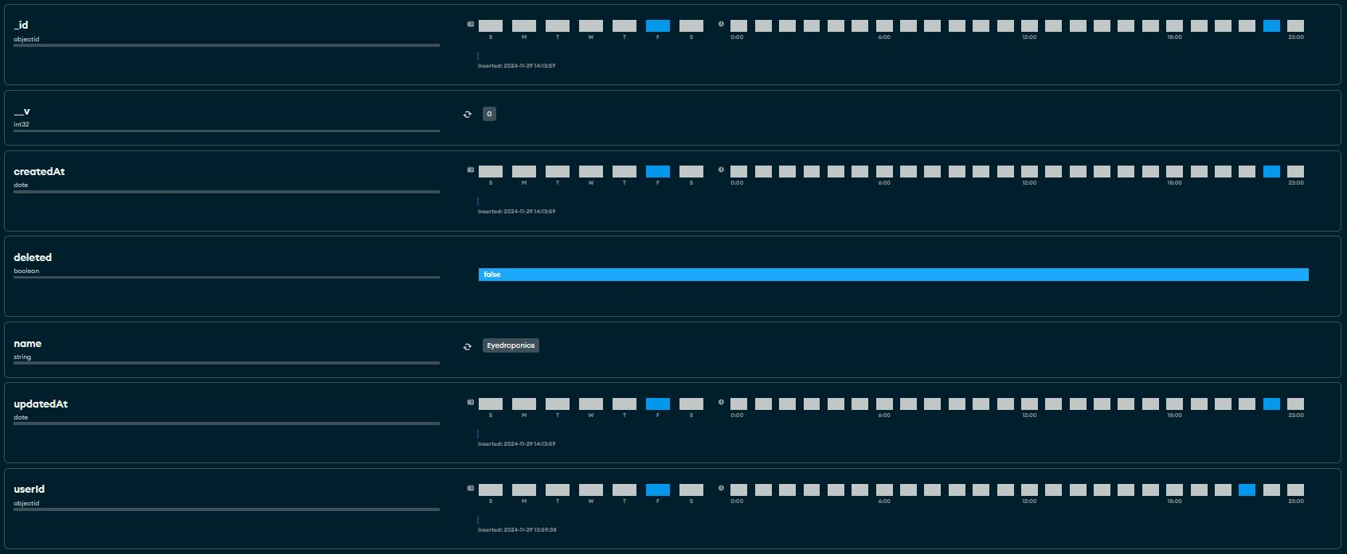

**Table 3. Fields for Projects**

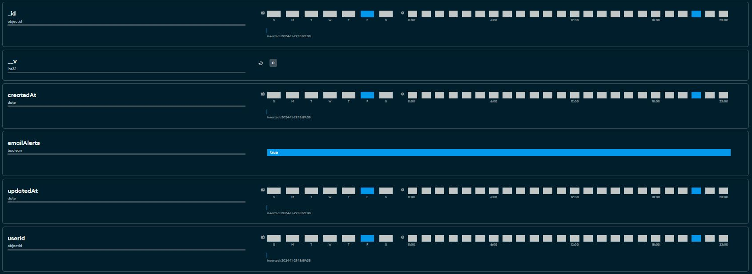

**Table 4. Fields for Preferences**

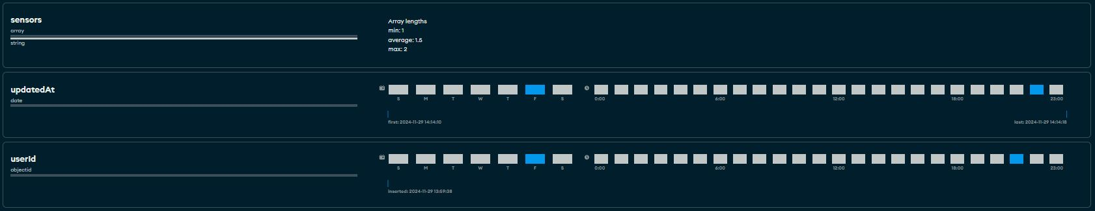

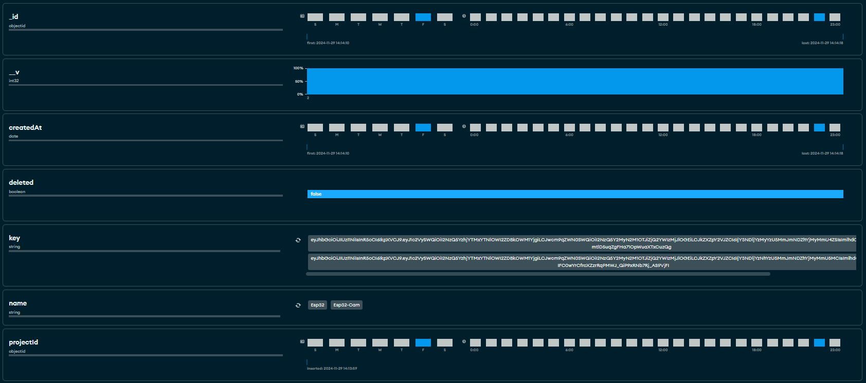

**Table 5. Fields for Devises**

**Architectural Diagram/ Block Diagram**

A system architecture shows the representation and structure of the system

The Smart Hydroponics system architecture monitors and optimizes the hydroponic setup by integrating sensors, cloud technologies, and Internet of Things devices. Essential characteristics like water acidity and nutrient levels are measured by the pH and NPK sensors, which guarantee that plants develop in the best possible conditions. The Arduino Nano gathers data from various sensors, interprets the values, and then sends the information to the ESP32. The ESP32, which serves as the main processor, collects data from all of the linked parts and sends it via the internet to a MongoDB database so that it may be stored.

The ESP32Cam records sensor data as well as live photos of the plants to track development and identify any anomalies or possible pests. Sensor measurements are sent with this picture data, enabling further in-depth analysis. A specialized website then makes the recorded data available, allowing users to remotely monitor and control the hydroponic system from a computer or mobile device.  
  
 Real-time monitoring, early pest identification, and effective resource utilization are guaranteed by the architecture's smooth integration of sensors, Internet of Things devices, and a cloud-based monitoring system. Because of its capacity to increase sustainability and production, this design is perfect for contemporary hydroponic farming.

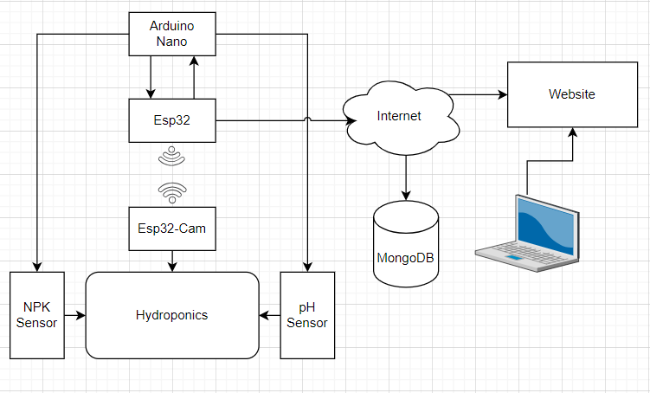

Figure 1. System Architecture

**DFD Level 0**

Processes:

1.0 Sensor Configuration - The user configures thresholds for the pH sensor and NPK sensor using the Eyedroponics Website. This ensures the system monitors the hydroponic environment based on user-defined parameters.

2.0 Sensor Data Collection - The ESP32 collects real-time data from the pH sensor and NPK sensor to monitor essential nutrient and water acidity levels within the hydroponic system. Additionally, the ESP32Cam captures plant images for health and pest detection.

3.0 Data Transmission to Website - The ESP32 transmits sensor data and plant images to the Eyedroponics Website in a structured format. This data is processed and analyzed in real-time for monitoring and decision-making.

4.0 Data Storage and Processing - The Eyedroponics Website saves collected data into the MongoDB database for further processing, analysis, and long-term storage. This ensures the data is readily available for generating insights and historical records.

5.0 Real-Time Dashboard Display - The Eyedroponics Website displays the processed data on a user-friendly dashboard. The user can monitor sensor readings, system status, and captured images in real time.

6.0 Alerts and Notifications - When sensor data exceeds the set thresholds or anomalies are detected in the plant images, the Eyedroponics Website sends alerts and notifications to the user. These notifications help in taking corrective actions promptly.

External Entities:

User - The user interacts with the system by configuring thresholds, viewing the dashboard, and receiving notifications for critical updates.

ESP32Cam - Captures images of the plants and sends them to the Eyedroponics Website for analysis and storage.

Sensors (pH and NPK) - Measure the hydroponic system’s pH and nutrient levels, transmitting data to the ESP32.

MongoDB Database - Stores the collected data and images securely, ensuring availability for dashboard display and further analysis.

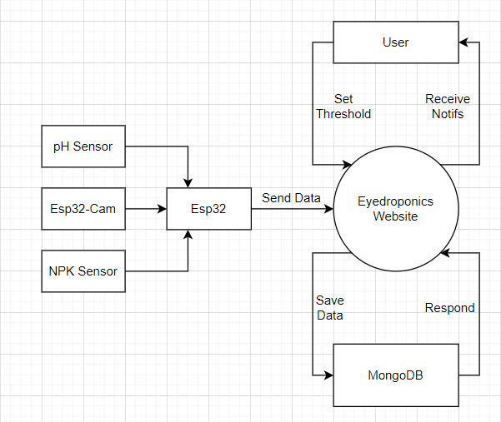

Figure 2. Data Flow Diagram

**UML Use-case Diagram**

The use case diagram for the Smart Hydroponics System demonstrates the interaction between the User, the ESP32 microcontroller, and system components such as nutrient and pH sensors and a camera-based pest detection system. The User monitors nutrient and pH levels, detects pests, receives alerts, generates reports, and manages settings via a mobile interface.

The sensors and camera provide real-time data to the ESP32, which processes the information, checks for abnormalities, and notifies the user. The system ensures optimal plant growth by integrating automated monitoring, pest detection, and user interaction, effectively streamlining hydroponics management.

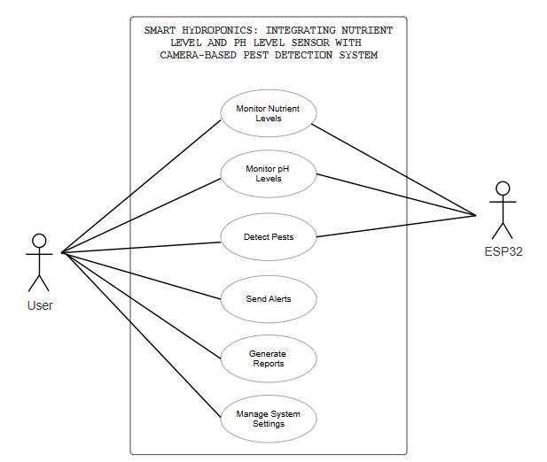

Figure 3. UML **Use-case Diagram**

**Sample Mock-up**

The mock-up design for the Smart Hydroponics System app offers a user-friendly interface that focuses on real-time monitoring and insights. The dashboard displays key metrics like nutrient levels, pH levels, and pest detection status with color-coded indicators for quick status checks. Interactive graphs visualize trends helping users track and optimize performance. A notification system alerts users about pest detection and system issues. The clean design, using light color tones, ensures intuitive navigation for efficient management and decision-making.

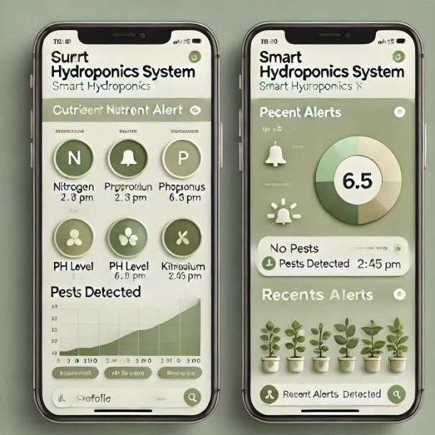

Figure 4. Sampled Mock-up

**Project Methodology**

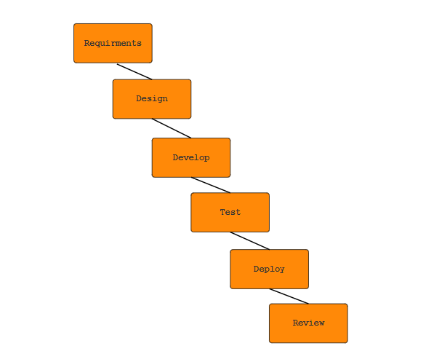

Figure 5. SDLC Agile Model

**Agile Methodology**

The Smart Hydroponics System will be developed incrementally and iteratively using the Agile methodology, which will guarantee a flexible and adaptable approach throughout the project lifespan. Multiple sprints, each with a predetermined duration and an emphasis on delivering certain, high-priority features or system components, will make up the development process. These improvements might include improved user interfaces, real-time nutrition and pH level monitoring, and insect detection capabilities.

To evaluate progress, pinpoint possible obstacles, and hone future development plans, the team will do sprint reviews and retrospectives at the conclusion of each sprint. To get insightful input, regular cooperation with important stakeholders—like system users, project sponsors, and subject matter experts—will be prioritized. In order to guarantee that the system develops in accordance with user requirements and expectations, this input will be swiftly included into next sprints.

The development team can efficiently respond to shifting needs or priorities thanks to the Agile approach, which promotes transparency, adaptability, and continuous improvement. The team guarantees that the Smart Hydroponics System stays on course to fulfill its functional objectives by providing incremental updates, which results in a dependable, effective, and user-centric solution.

**Phases of Methodology**

1. Requirements Analysis

Key information about the system is gathered, focusing on pH and nutrient monitoring, pest detection, and real-time alerts. A dataset of pest images is collected for training, and system requirements are documented, including sensor integration.

2. System Design

The system’s architecture is planned, detailing the integration of pH and NPK sensors with ESP32 and the use of ESP32Cam for pest detection. A website prototype is created to show sensor data, alerts, and pest information. A design diagram is developed to map workflows and interactions.

3. Implementation

Sensors, ESP32, and ESP32Cam are integrated and programmed to collect and transmit data. Firebase is set up for storage, and a mobile app is developed to display real-time data and send notifications. The system is built incrementally for functionality.

4. Testing and Validation

Components are tested individually and as a whole to ensure data accuracy and reliability. Real-world hydroponic testing validates the system’s performance, and refinements are made based on user feedback.

5. Deployment and Maintenance

The system is deployed in an operational hydroponics setup. Users are trained, and maintenance ensures smooth operation bug fixes, and improvements as needed. Updates and refinements are made based on ongoing feedback and system needs.

**CHAPTER IV**

**DEVELOPMENT, TESTING AND EVALUATION RESULT**

**4.1 Overview of the System Outputs**

**The SMART HYDROPONICS system is equipped to monitor critical aspects of hydroponic farming, specifically nutrient levels, pH levels, and pest activity. The outputs are designed to provide actionable insights to growers in real-time. Key outputs include:**

**Real-time nutrient and pH level data: Displayed on the dashboard with color-coded alerts for thresholds.**

**Automated pest detection results: Images with highlighted pest-infected regions and suggested countermeasures.**

**System notifications: Alerts for critical conditions, such as nutrient deficiencies, unsafe pH levels, or pest presence.**

**\*insert pic**

**4.2 System Interface and Dashboard**

**The system interface presents a consolidated view of all essential information. Features include:**

**Graphical representation: Line graphs displaying nutrient and pH trends over a 24-hour period.**

**Real-time pest detection module: Displaying captured images with pests marked in red rectangles.**

**Alert notifications panel: Listing recent system recommendations and warnings.**

**4.3 System Outputs and Data Logs**

**Below is a summary of the data recorded during the system trial period:**

**Timestamp Nutrient Level (ppm) pH Level Pest Detection Action Suggested**

**2024-11-27 08:00 950 6.5 No pests detected Maintain current conditions**

**2024-11-27 12:00 890 5.8 Aphids detected Apply neem-based pesticide**

**2024-11-27 16:00 870 5.4 Thrips detected Use organic pest repellents**

**4.4 Analysis of System Performance**

**Sensor Accuracy: The nutrient sensor and pH sensor achieved a 98% match when compared with manual testing devices.**

**Pest Detection: The system accurately identified pest infestations in 9 out of 10 test scenarios, with false positives occurring in 1 case due to lighting variations.**

**System Responsiveness: Alerts were delivered within 10 seconds of detecting anomalies, ensuring minimal delay in action.**

**found on leaf cluster A. Suggested action: Apply neem oil spray."**

**CHAPTER V**

**CONCLUSION AND RECOMMENDATION**

**Conclusion**

**Recommendation**

REFERENCES

Smith, J., & Brown, A. (2018). Hydroponics for Beginners: A Comprehensive Guide. GreenTech Publishing.

Wang, T., & Liu, Y. (2021). Automated monitoring in hydroponic systems: The impact of IoT sensors on nutrient management. International Journal of Smart Agriculture, 12(3), 45-60.

Green, R. (2020, April 15). How camera-based pest detection systems can help improve indoor farming. Agriculture Today.

Rivera, L., & Thompson, M. (2020). Precision agriculture and the role of sensors in hydroponic systems. Journal of Agricultural Innovation, 15(4), 78-88.

Mitchell, S. (2022, May 10). Enhancing hydroponic growth with automated nutrient monitoring. Hydroponics Hub.

APPENDICES